Measles and Rubella Risk Assessment Final Report - Caribbean

Measles and Rubella Risk Assessment Profile - Caribbean, 03.11.2024



# Background

The Pan American Health Organization/World Health Organization (PAHO/WHO) Measles and Rubella Risk Assessment Tool identifies areas that are not meeting programmatic targets for measles and rubella. Therefore, the results of the risk assessment will guide and strengthen activities for the sustainable elimination of these diseases, in order to educate the risk of outbreaks.

This tool assesses risk at the país level by summing indicator points in five categories: population immunity, surveillance quality, program performance, threat assessment, and rapid response. Each paísity in the country is assigned a programmatic risk category: low, medium, high, or very high , based on the final score obtained. The scoring for each indicator was based on expert consensus. The range of possible scores goes from 0 to 100 risk points, according to the following table:

| Risk categories | Total Risk Points |
| --- | --- |
| Low risk | Less than 26 points |
| Medium risk | Between 26 and 50 points |
| High risk | Between 51 and 75 points |
| Very high risk | More than 100 points |

## Risk indicators

* Population immunity: Evaluates susceptibility risk for measles and rubella using reported administrative coverage for the first and second doses of measles-mumps-rubella vaccine (MMR1 and MMR2, respectively); and the coverage obtained in the latest follow-up campaign carried out in the country. This indicator also includes the proportion of suspected cases of measles and rubella who were not vaccinated or whose vaccination history is not known. (Total points = 40)
* Surveillance quality: Evaluates the sensitivity of the paísity for timely detection and confirmation of measles and rubella cases. Indicators in this category include the annual reporting rate for suspected cases of measles and rubella; the proportion of suspected cases with adequate investigation (home visit within 48 hours after notification and completion of eight of the 11 key variables); the proportion of cases with an adequate sample in < 30 days; and the proportion of blood samples received in the laboratory in < 5 days. (Total points = 20)
* Program performance: Evaluates specific aspects of routine immunization services, including administrative coverage indicators for MMR1 and MMR2; drop-out rate for MMR1-MMR2; and for the first dose of pentavalent vaccine (diphtheria-tetanus-pertussis [DTaP], hepatitis B, and Haemophilus influenzae) and MMR1. (Total points = 16)
* Threat assessment: Considers factors that may influence the risk of introduction and spread of measles and rubella in the population. These indicators include population density and the presence of vulnerable groups. (Total points = 12)
* Rapid response to imported cases of measles and rubella: Considers the presence of a rapid response to imported cases of measles and rubella. Indicators are measured at the subnational level and include the presence of a trained rapid response team and the proportion of hospitals trained to triage and isolate highly suspected cases of measles and rubella. (Total points = 12)

The tool can be used periodically by managers of national immunization, epidemiological surveillance, and laboratory programs to monitor implementation of measles and rubella sustainability strategies in the country. The tool requires data that is readily available and routinely collected by immunization and surveillance programs. Results are visualized through tables and maps, by paísity, with colors assigned to each risk category. In addition, país risk scores can be displayed by indicator, facilitating a better understanding of the programmatic weaknesses contributing to the final risk assessment score.

## Section 1: Overall measles and rubella risk profile

From 21 countries in Caribbean, 0 (0%) were categorized as very high risk, 6 (28.6%) were categorized as high risk, 15 (71.4%) were categorized as medium risk, and 0 (0%) were categorized as low risk.

#### Table 1a: Number of paísities in general profile, Caribbean, 2019-2023.

| Risk categories | Number of countries | % of countries |
| --- | --- | --- |
| Low risk | 0 | 0.0% |
| Medium risk | 15 | 71.4% |
| High risk | 6 | 28.6% |
| Very high risk | 0 | 0.0% |
| Total | 21 | 100.0% |

#### Figure 1a: Risk assessment for measles and rubella Caribbean, 2019-2023.

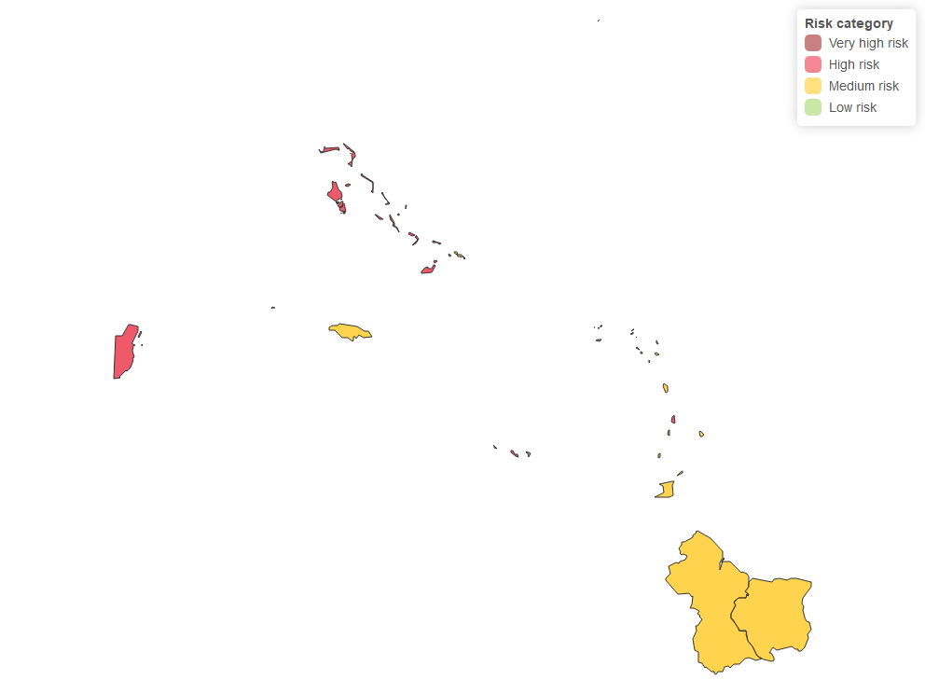

#### Figure 1b: Risk map for very high-risk paísities, Caribbean, 2019-2023.

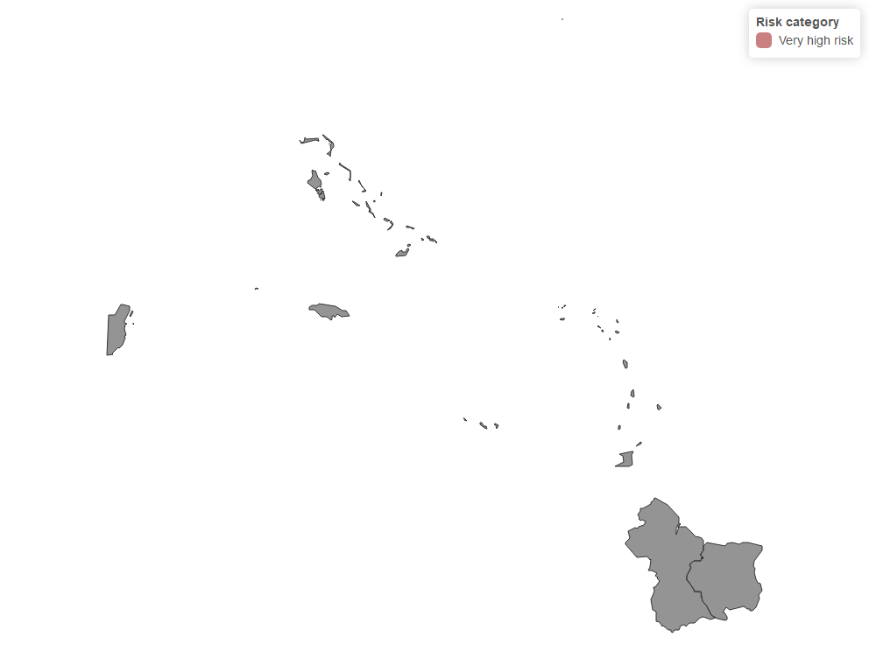

#### Figure 1c: Risk map for high-risk paísities, Caribbean, 2019-2023.

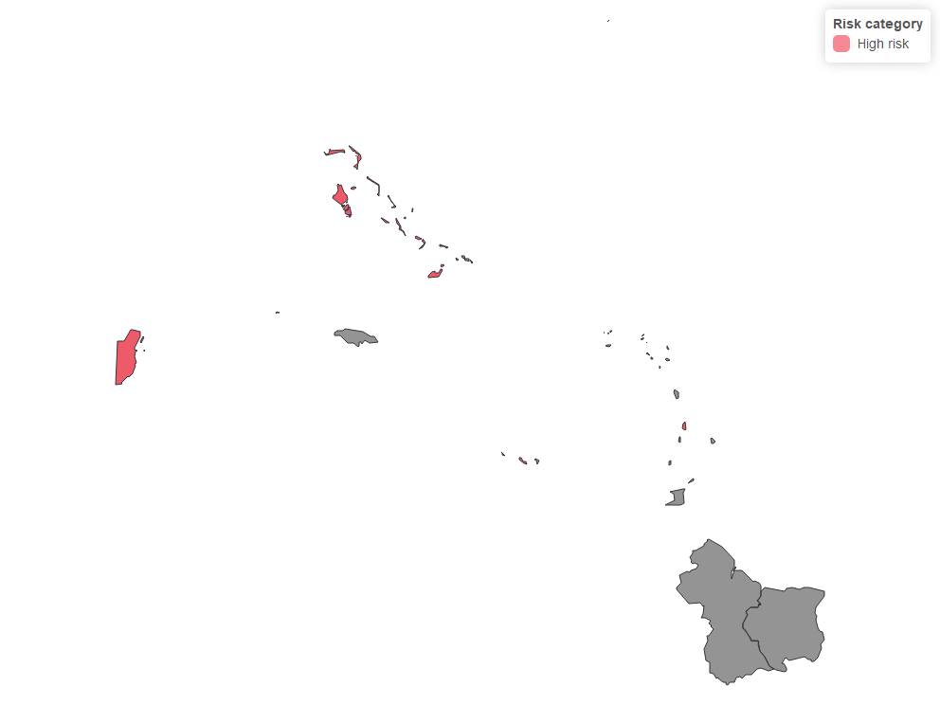

## Section 2: Population Immunity

#### Table 2a: Number of countries with population immunity, Caribbean, 2019-2023.

| Population Immunity | Number of countries | % of countries |
| --- | --- | --- |
| Low risk | 7 | 33.3% |
| Medium risk | 11 | 52.4% |
| High risk | 3 | 14.3% |
| Very high risk | 0 | 0.0% |
| Total | 21 | 100.0% |

#### Figure 2a: Risk assessment for population immunity, Caribbean, 2019-2023.

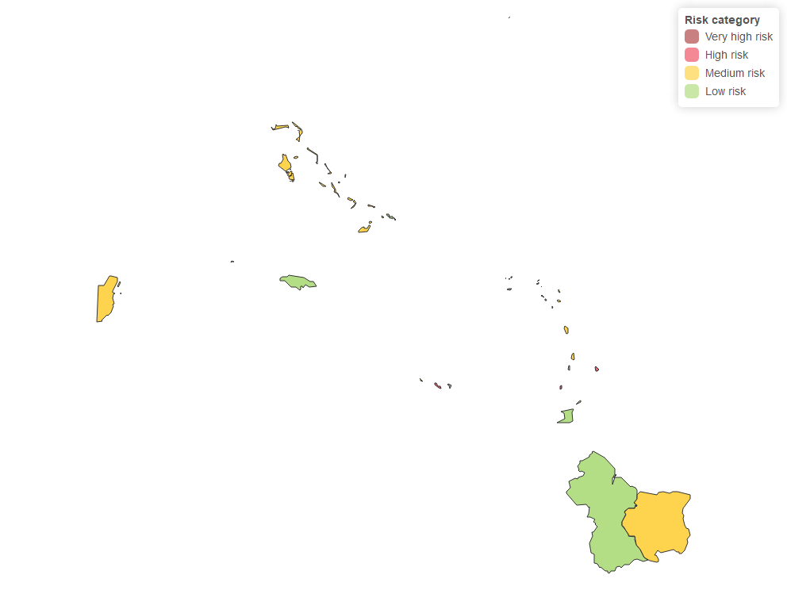

#### Figure 2b: Coverage of measles-rubella (MR) campaign, Caribbean, 2023.

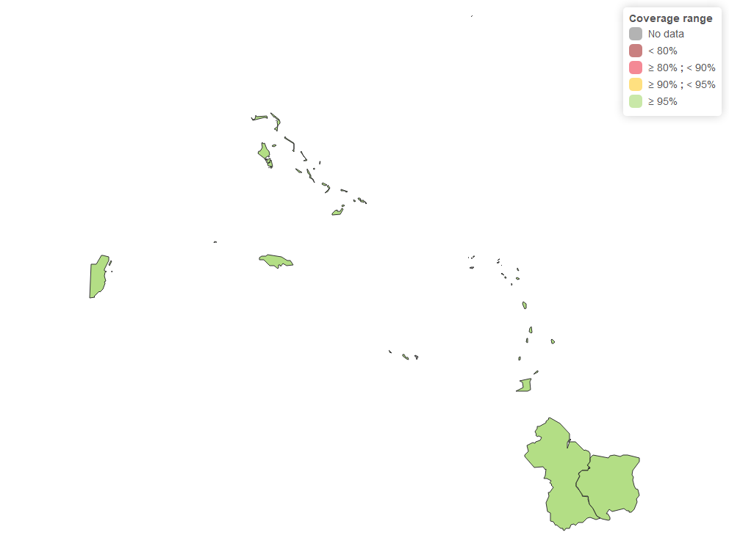

#### Figure 2c: MMR1 coverage, Caribbean, 2019.

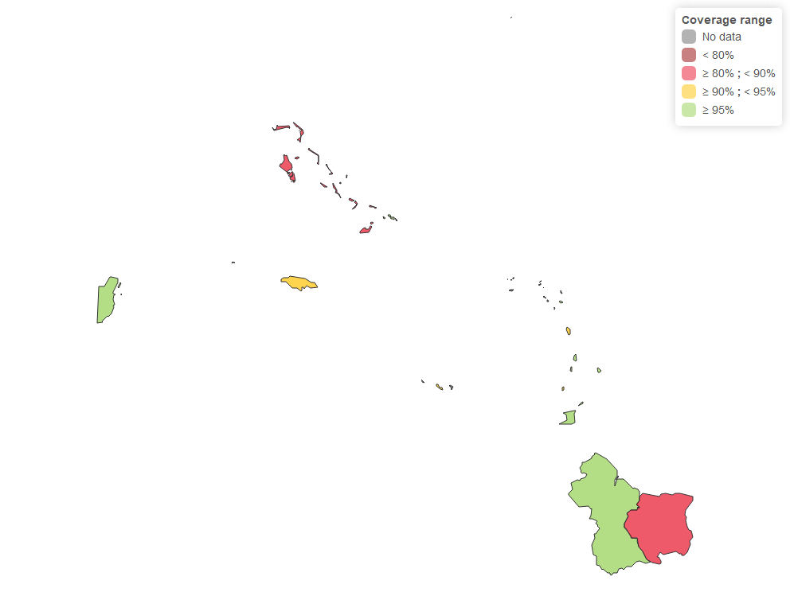

#### Figure 2d: MMR1 coverage, Caribbean, 2020.

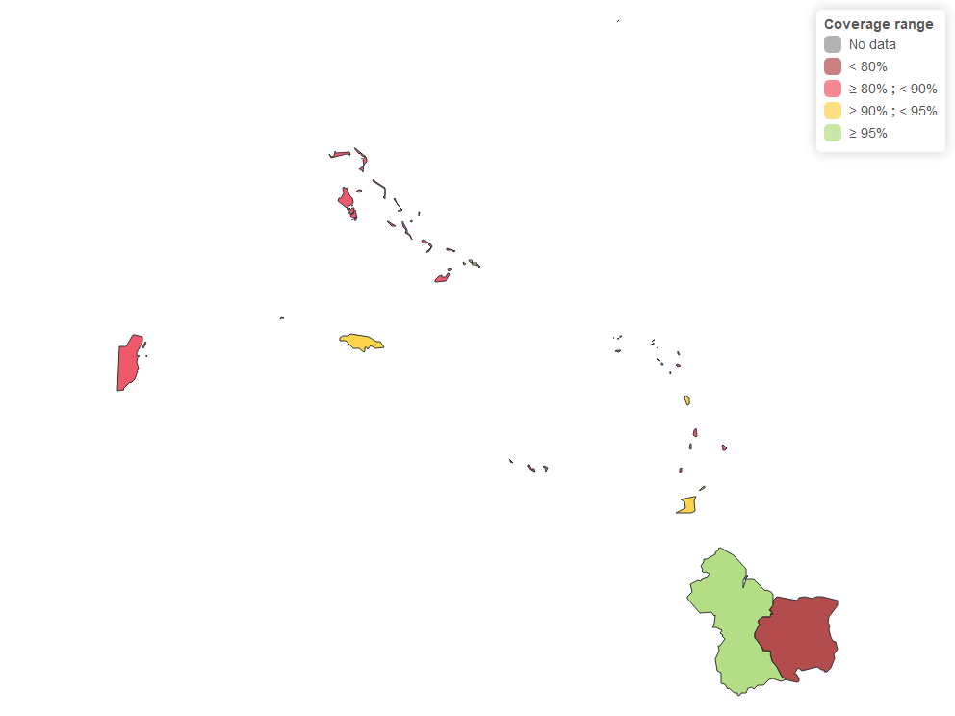

#### Figure 2e: MMR1 coverage, Caribbean, 2021.

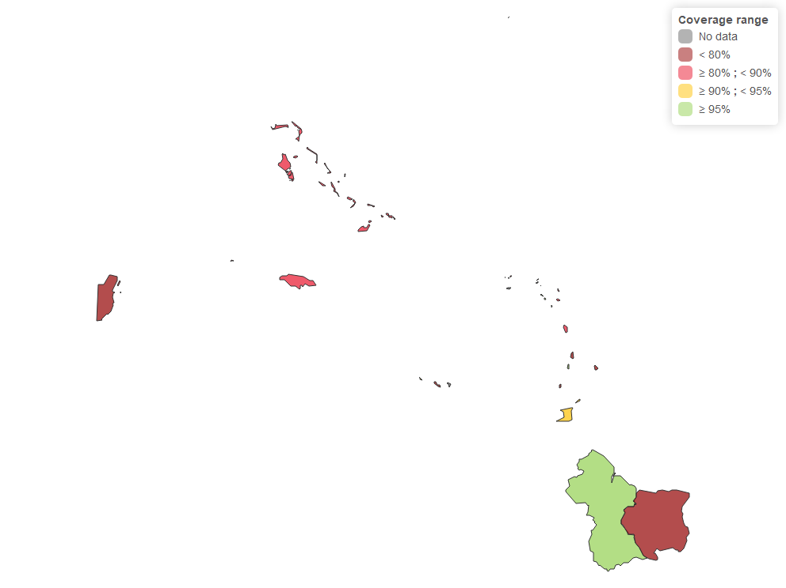

#### Figure 2f MMR1 coverage, Caribbean, 2022.

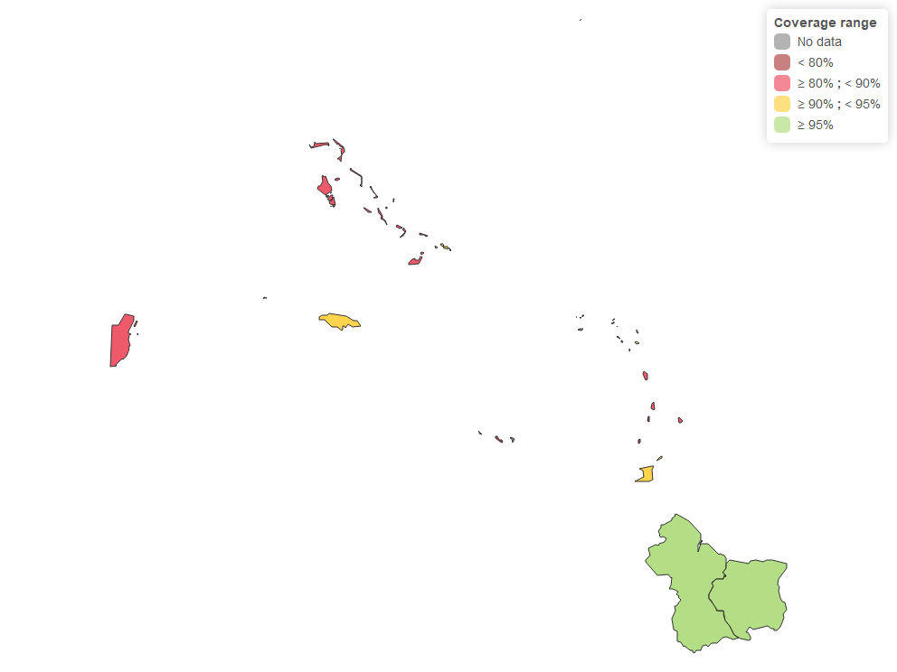

#### Figure 2g: MMR1 coverage, Caribbean, 2023.

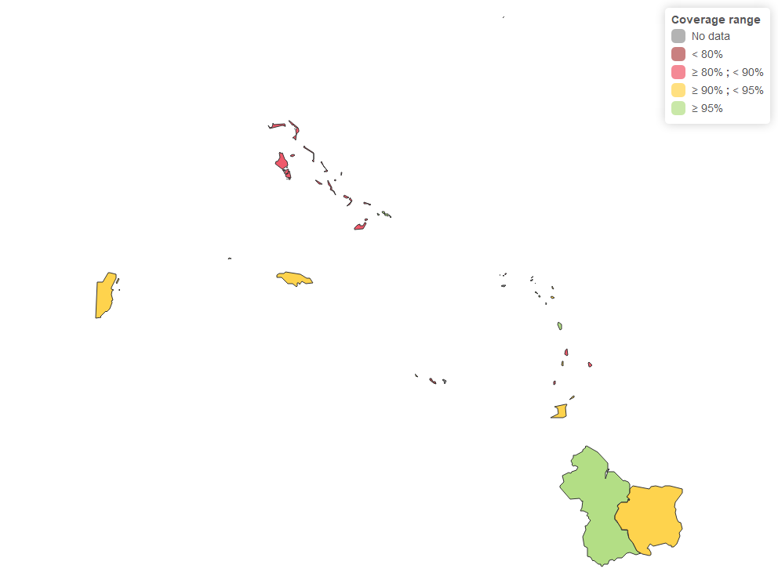

#### Figure 2h: MMR2 coverage, Caribbean, 2019.

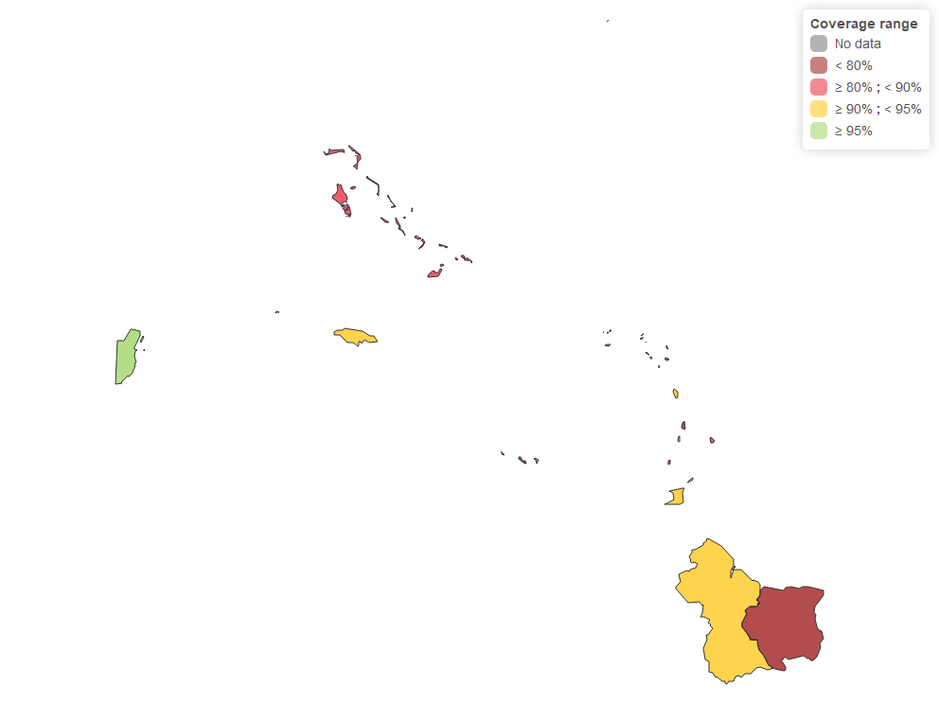

#### Figure 2i: MMR2 coverage, Caribbean, 2020.

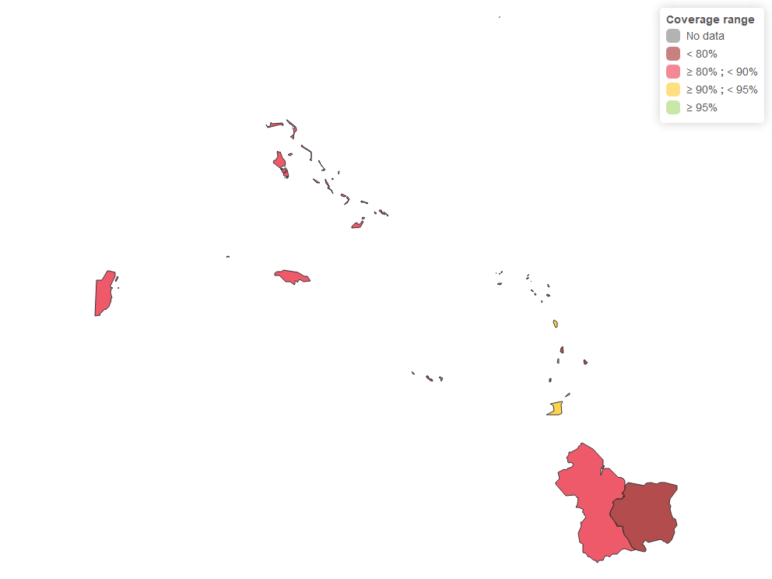

#### Figure 2j: MMR2 coverage, Caribbean, 2021.

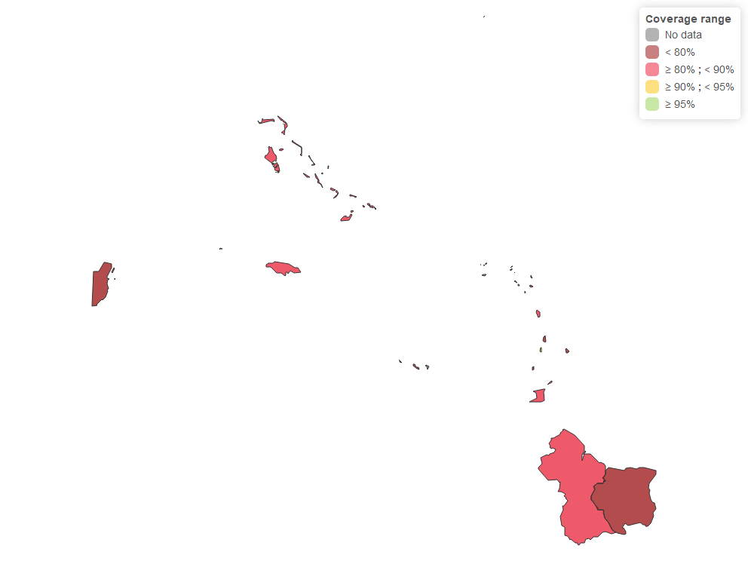

#### Figure 2k: MMR2 coverage, Caribbean, 2022.

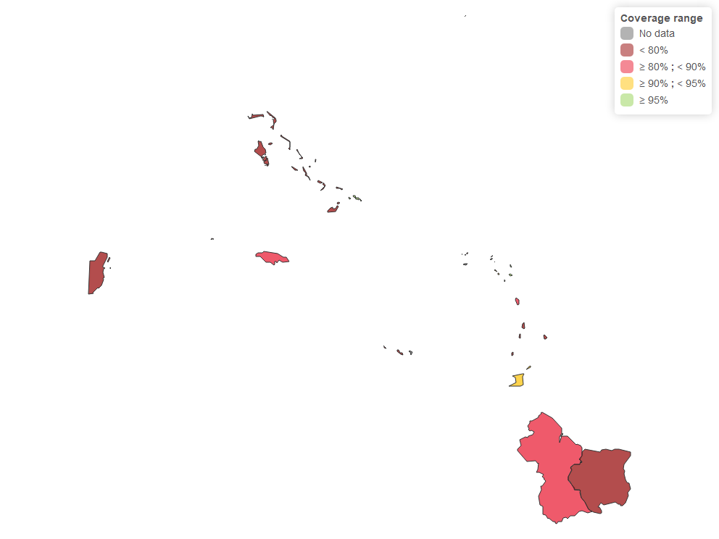

#### Figure 2l: MMR2 coverage, Caribbean, 2023.

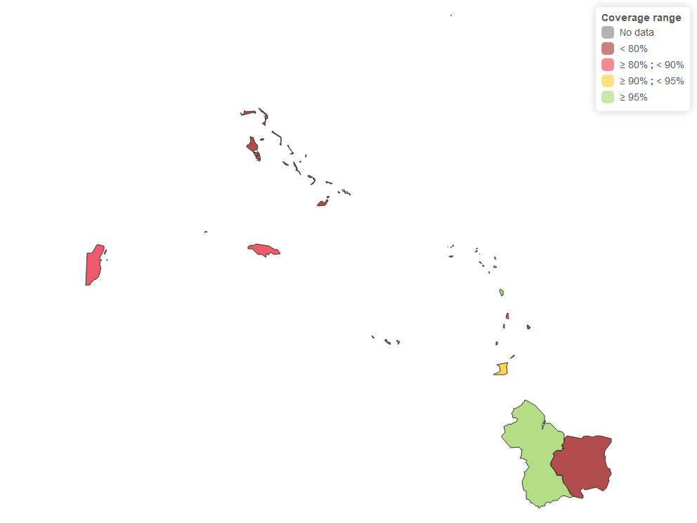

## Section 3: Surveillance Quality

#### Table 3a: Number of countries under surveillance, Caribbean, 2019-2023.

| Surveillance Quality | Number of countries | % of countries |
| --- | --- | --- |
| Low risk | 2 | 9.5% |
| Medium risk | 5 | 23.8% |
| High risk | 11 | 52.4% |
| Very high risk | 3 | 14.3% |
| Total | 21 | 100.0% |

#### Figure 3a: Risk assessment for surveillance quality, Caribbean, 2023.

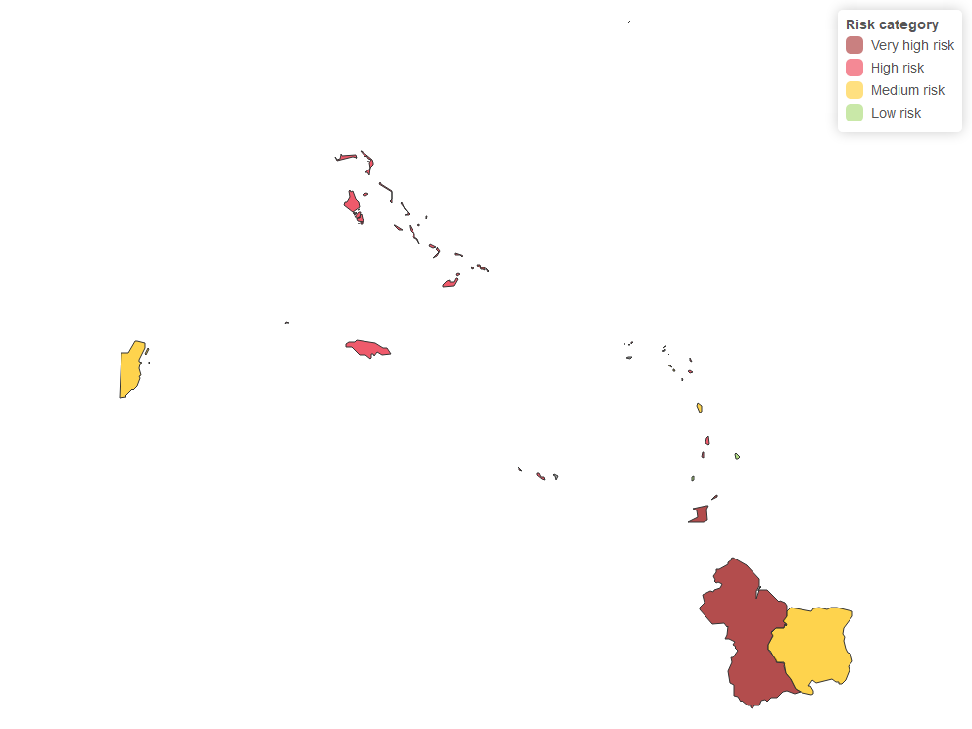

#### Figure 3b: Annual reporting rate of suspected measles and rubella cases per 100,000 population1, Caribbean, 2023.

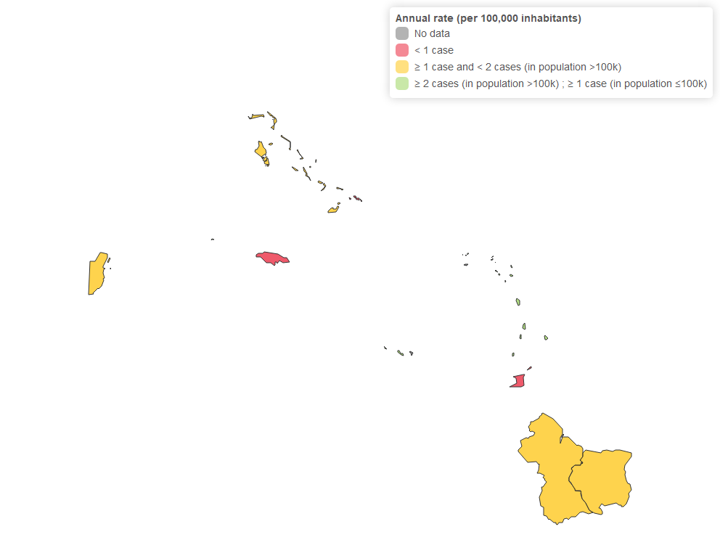

1 When a country has fewer than 100,000 inhabitants and has reported at least one suspected case in the most recent year, the tool assigns 0 risk points.  If the paísity has been in epidemiological silence (has not reported any cases), the tool will assign the maximum risk score (8 points).

#### Figure 3c: Proportion of suspected cases with adequate investigation, Caribbean, 2023.

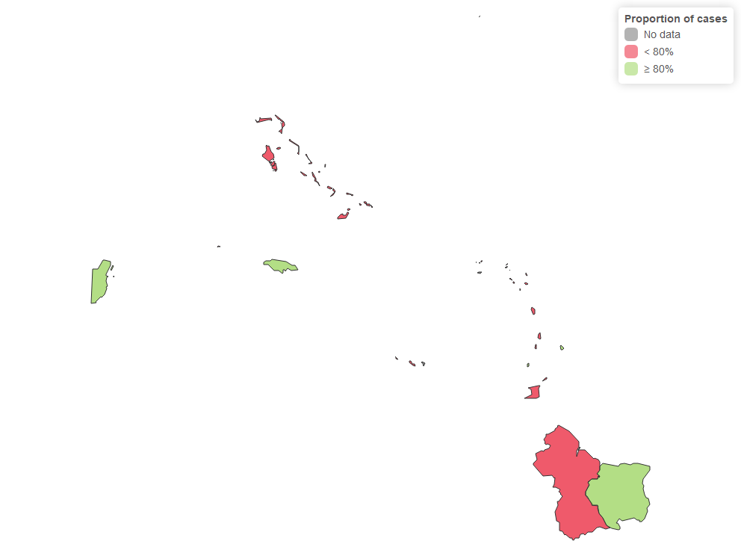

#### Figure 3d: Proportion of suspected cases with adequate sample, Caribbean, 2023.

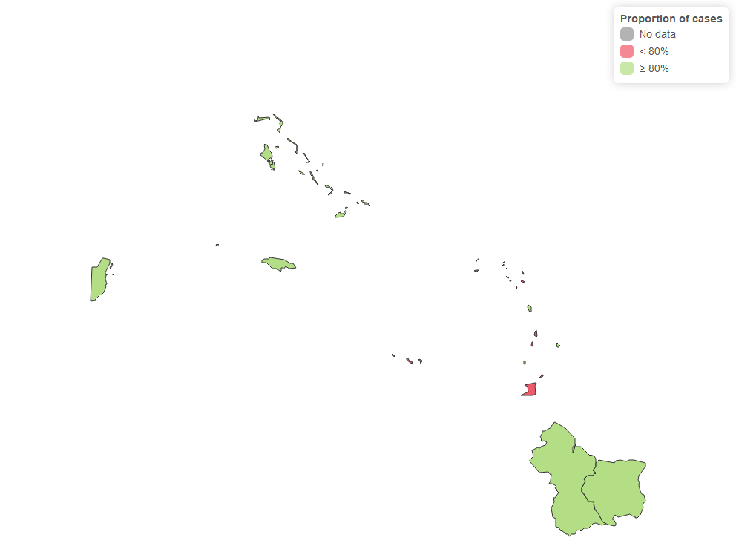

#### Figure 3e: Proportion of samples sent to the laboratory in <= 5 days, Caribbean, 2023.

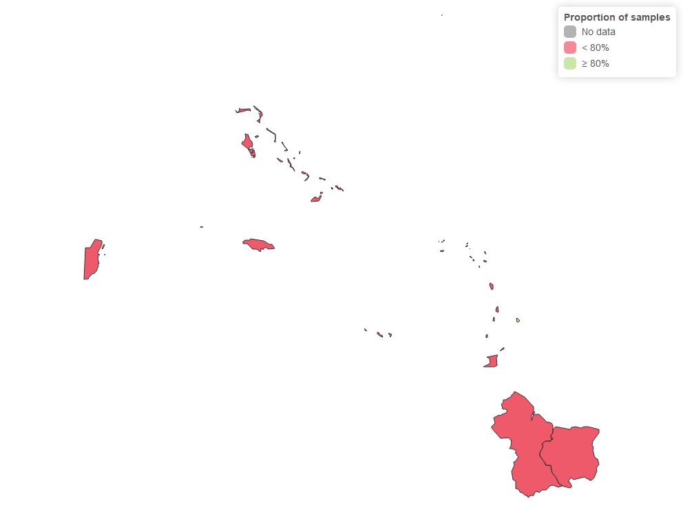

### Table 3b: Silent countries, Caribbean, 2019-2023.

#### Figure 3f: Silent countries, Caribbean, 2023.

NR

## Section 4: Program Delivery Performance

#### Table 4a: Number of paísities in program performance, Caribbean, 2019-2023.

| Program Delivery Performance | Number of countries | % of countries |
| --- | --- | --- |
| Low risk | 6 | 28.6% |
| Medium risk | 9 | 42.9% |
| High risk | 6 | 28.6% |
| Very high risk | 0 | 0.0% |
| Total | 21 | 100.0% |

#### Figure 4a: Risk assessment for program performance, Caribbean, 2019-2023.

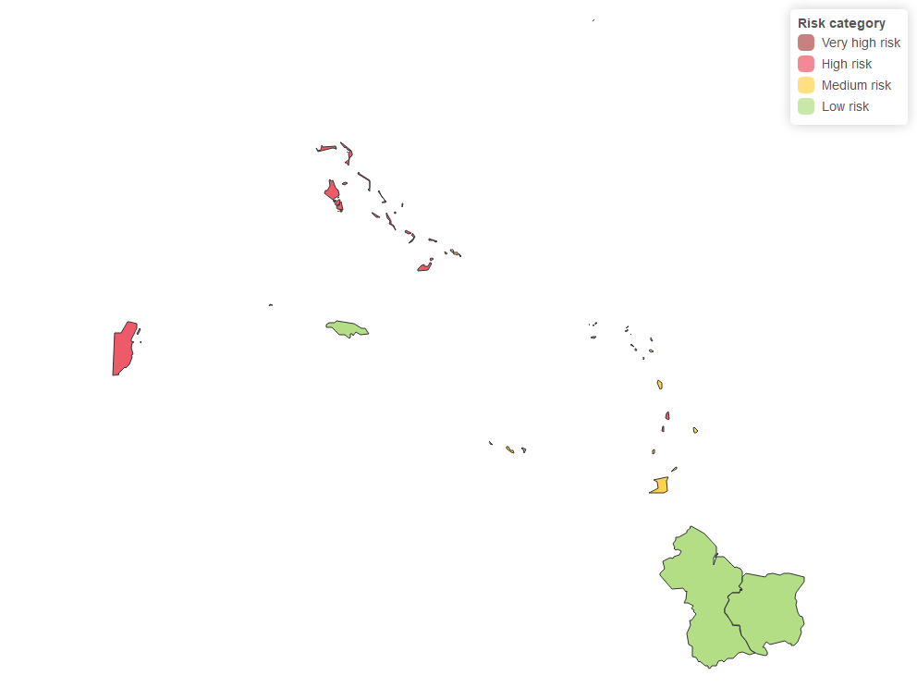

#### Figure 4b: MMR1 trend, Caribbean, 2019-2023.

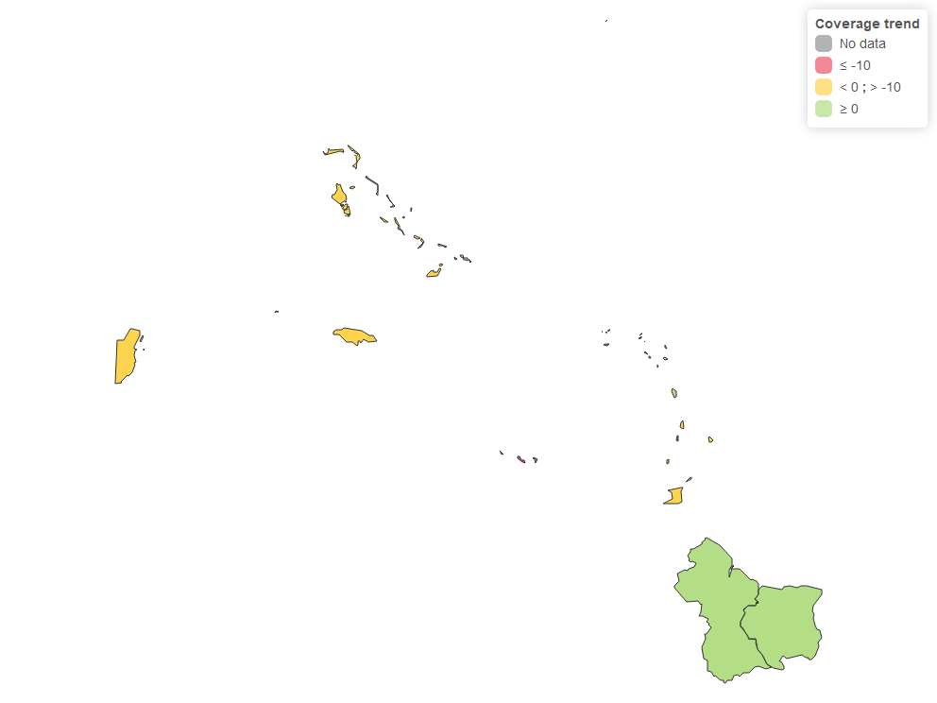

#### Figure 4c: MMR2 trend, Caribbean, 2019-2023.

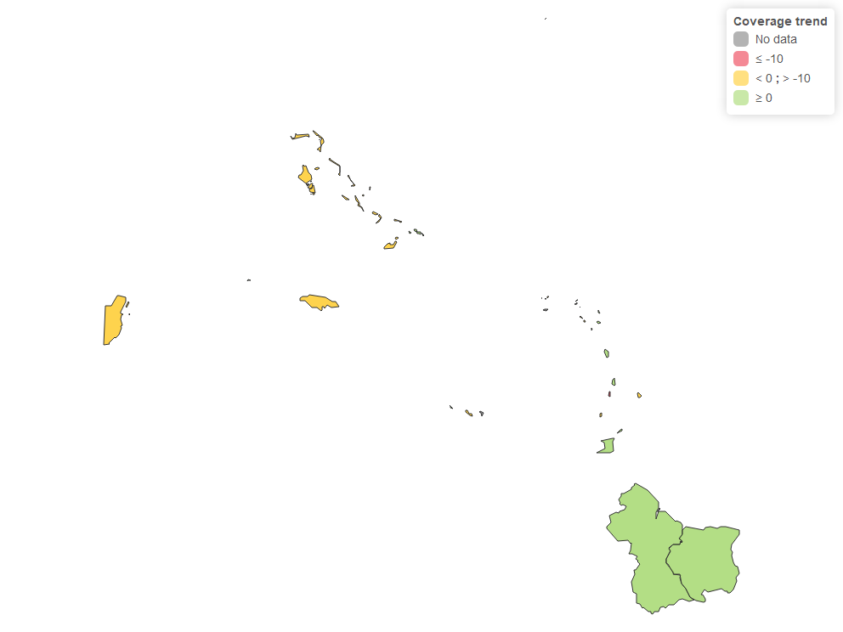

#### Figure 4d: Drop-out rate MMR1-MMR2, Caribbean, 2023.

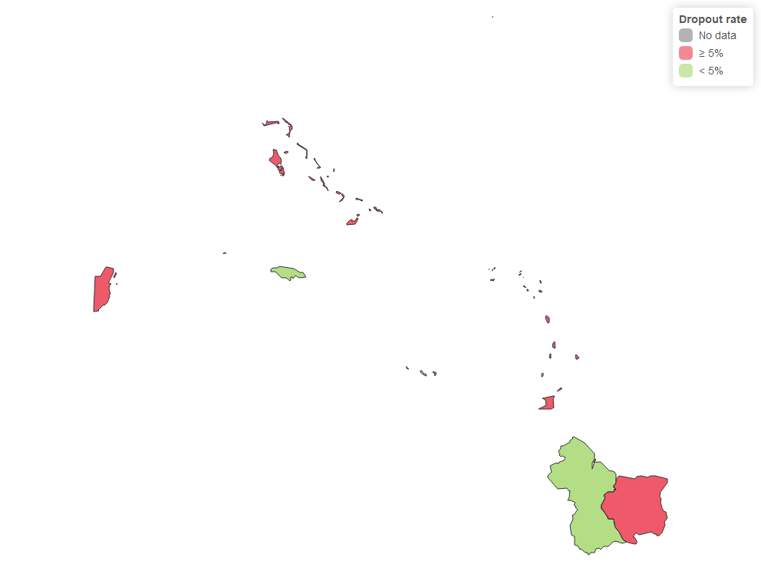

#### Figure 4e: Drop-out rate Penta1-MMR1, Caribbean, 2023.

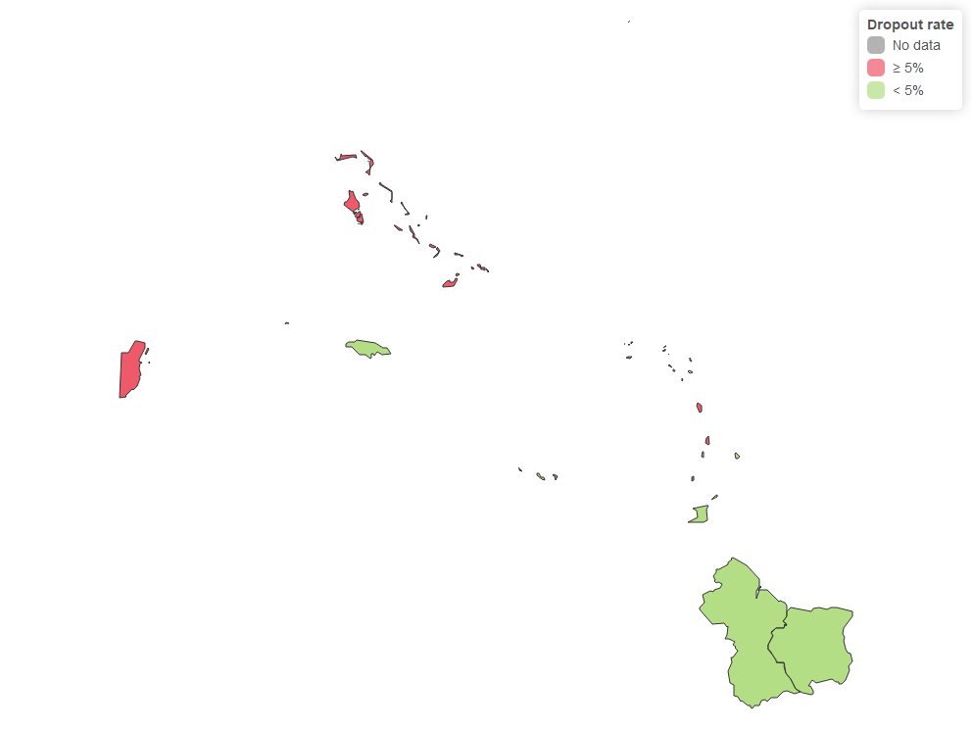

## Section 5: Threat Assessment

#### Table 5a: Number of paísities in threat assessment, Caribbean, 2019-2023.

| Threat Assessment | Number of countries | % of countries |
| --- | --- | --- |
| Low risk | 0 | 0.0% |
| Medium risk | 16 | 76.2% |
| High risk | 5 | 23.8% |
| Very high risk | 0 | 0.0% |
| Total | 21 | 100.0% |

#### Figure 5a: Risk profile for threat assessment, Caribbean, 2019-2023.

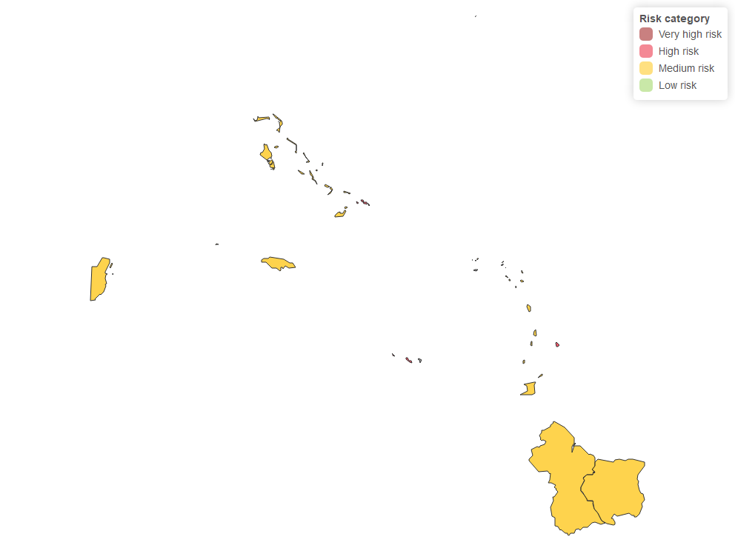

#### Figure 5b: Population density (per km2), Caribbean, 2019-2023.

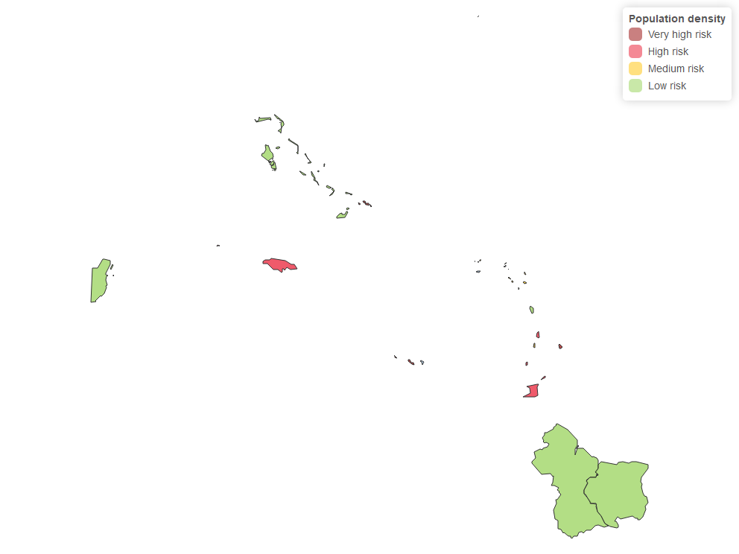

#### Figure 5c: Presence of vulnerable population, Caribbean, 2023.

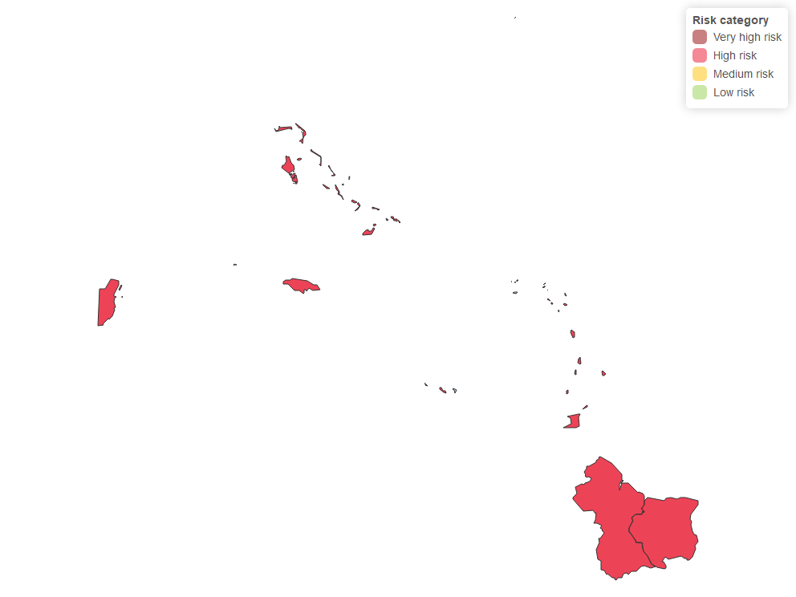

## Section 6: Rapid response to imported cases

#### Table 6a: Number of paísities in rapid response, Caribbean, 2019-2023.

| Rapid response to imported cases | Number of countries | % of countries |
| --- | --- | --- |
| Low risk | 0 | 0.0% |
| Medium risk | 21 | 100.0% |
| High risk | 0 | 0.0% |
| Very high risk | 0 | 0.0% |
| Total | 21 | 100.0% |

#### Figure 6a: Risk assessment for rapid response to imported cases, Caribbean, 2019-2023.

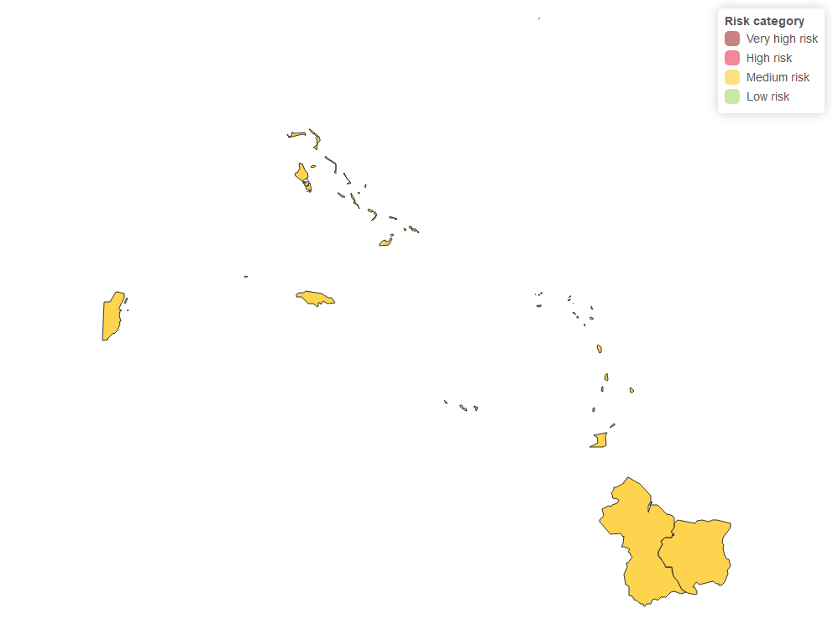

#### Figure 6b: Presence of trained rapid response team at subnational level, Caribbean, 2019-2023.

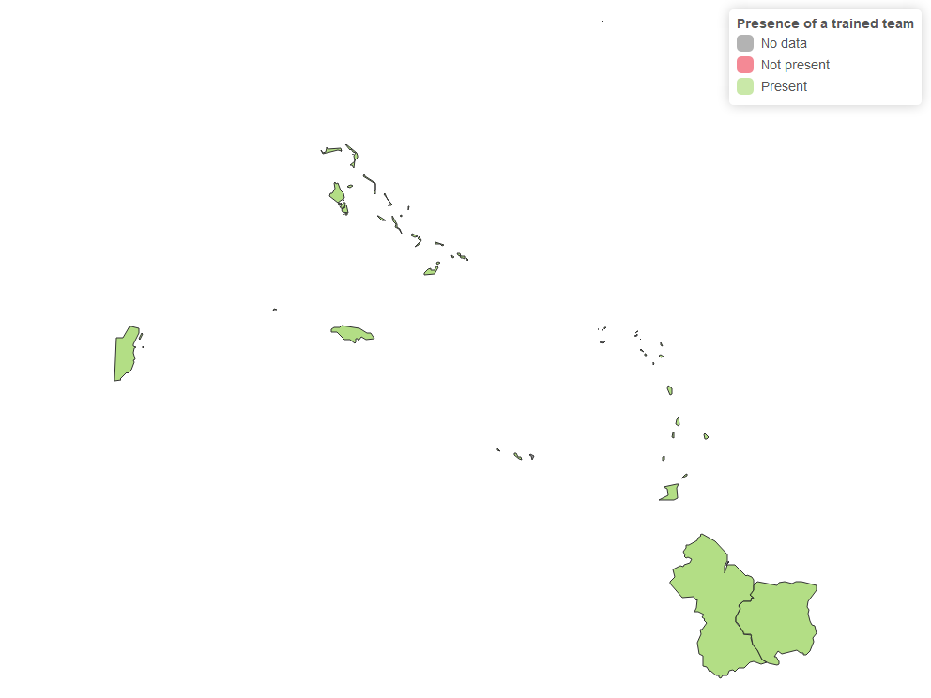

#### Figure 6c: Percentage of hospitals at subnational level with staff trained in triage and isolation, Caribbean, 2019-2023.

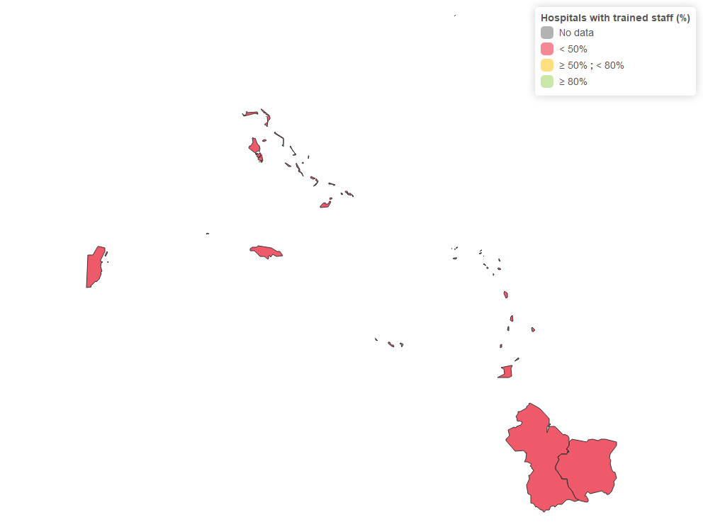

# Appendix: Global variables

#### Global reference data

| Global reference data | Value |
| --- | --- |
| Name of country or subnational level | Caribbean |
| Year of risk assessment | 2024 |
| Does the country have a trained rapid response team? | Si |
| Year of last campaign (YYYY)? | 2023 |
| MMR1 age of administration (months) | 12 |
| MMR2 age of administration (months) | 18 |
| Outbreak | No |
| Language | ENG |

#### Calculated fields

| Calculated fields | Value |
| --- | --- |
| First year of data | 2019 |
| Last year of data | 2023 |
| Years of assessment | 2019-2023 |

#### Geoelement

| Geoelement | Value |
| --- | --- |
| Shapefiles loaded | 26 |
| Number of subnational levels | 1 |
| Number of countries | 26 |
| Population of country in reference year | 8,057,839 |
| Area (km2) in reference year | 425,291.2 |